## FO On prem to cloud Cluster:

1. Create the mobility group with the shared cluster disk and start replication. Create another group with the boot disk of one of the cluster nodes and start the replication on that as well.
2. Add the correct values in the JSON file of the mobility group that has the shared disk and create the RG. Optionally add the RG for the MG with the root disk replication pair.
3. Monitor the status of the group from RO Monitor page after selecting the RG added above.   
   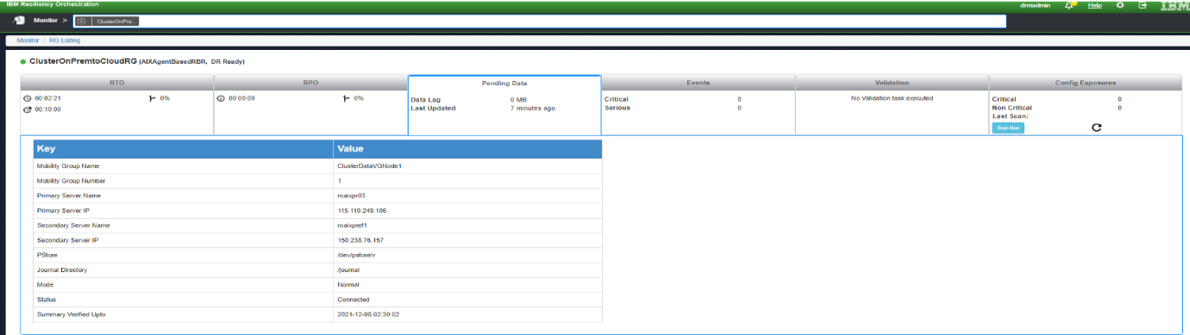
4. After the groups is in normal state, goto manage and select the RG.  
   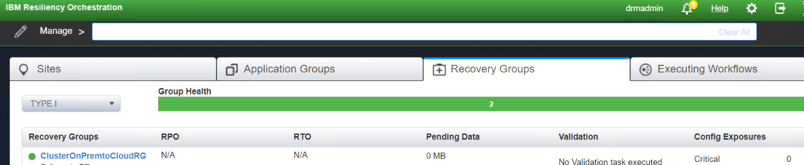
5. Go to the ‘Continuity Workflows’ section and select ‘View all workflows ‘. Edit the Failover workflow. Download the failover xml file from RO cli path $EAMSROOT/rpd/solutionPlugins/AIXAgentBasedRBR/ibm_cloud_cluster_fo.xml and import the new workflow.  
   Here, we will add an additional step to monitor the AIX LPAR creation. Click on ‘Add’ and select IBMPcloud and click on the add button for ‘GetInstanceStatus’.  
     
   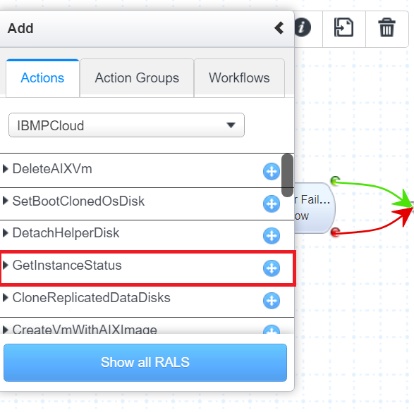

Place the newly added RAL as the second RAL. Select the RAL and click on the ‘Retry on Failure’ checkbox and add a retry count of 60.  
  
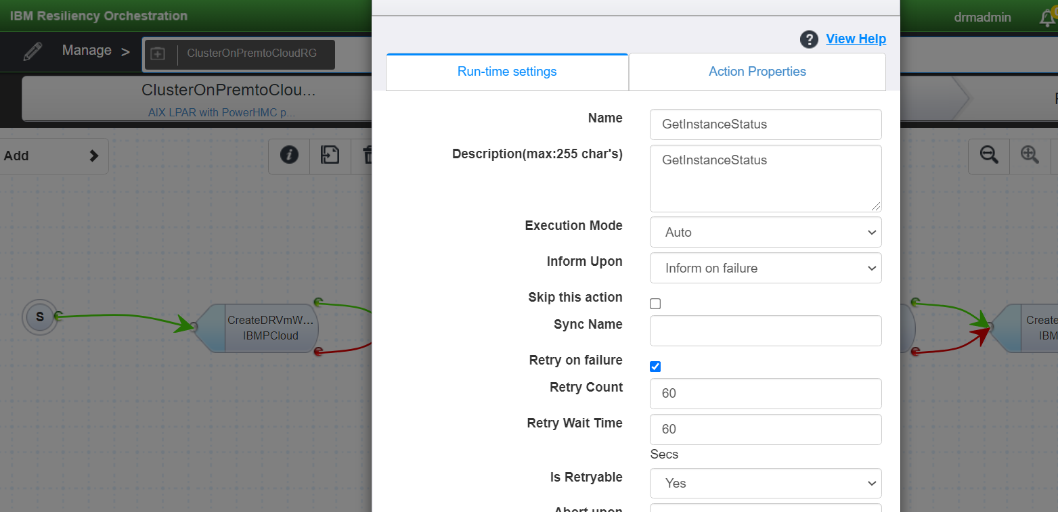  
  
Save the workflow and go to the next page and add the disks of both the groups and publish the workflow. After publishing the workflow start the execution of the workflow.  
  
FO Steps:

|  |
| --- |
| 1. CreateDRVmWithSelectedImage 2. GetInstanceStatus |
| 1. GetDRVmRootVolInfo |
| 1. StopDRVm |
| 1. CreateTempDisk |
| 1. MakeTempDiskBootable |
| 1. CheckReplStatus |
| 1. TDMF failover |
| 1. TDMF failover |
| 1. CloneReplicatedOSDisk |
| 1. CloneReplicatedDataDisks |
| 1. SetClonedOsDiskBootable |
| 1. AttachTempDiskToDRVm |
| 1. AttachClonedDataDisksToDRVm |
| 1. SetTempDiskAsDRVmBootDisk |
| 1. DetachDRVmRootDisk |
| 1. AttachClonedOSdisk |
| 1. DeleteDetachedRootDisk |
| 1. SetBootClonedOsDisk |
| 1. DetachTempDisk |
| 1. DeleteTempDisk |
| 1. StartDRVm |
| 1. GetDRVmDetails |